WELCOME TO GREENSIDE CRICKET CLUB

2019 MEMBER PACK
U18S

Welcome to Greenside Cricket Club

There are a few things across the next few pages that we need you to read as part of your membership role.

We expect all member to abide by the rules and conduct of play. We also expect you to take responsibility to report anyone breaching these rules which can be done confidentially by emailing greensidecricketclub@gmail.com

Please complete the membership form at the rear of this pack.
As a member, you are responsible for payment of Subscriptions in full during the season. Options are outlined at the rear of this pack too.
Keep up to date via the website www.greensidecricketclub.co.uk or look for our monthly season Newsletters to see what we’re up to and news on events.

Code of Conduct for Cricket Club Members and Guests*

GREENSIDE CRICKET CLUB

- Members and Guests of Greenside Cricket Club are required to abide by the provisions of this Code of Conduct and any subsequent updates as may be in force from time to time, and by their presence on club premises or at club events or activities are deemed to have accepted and to abide by the provisions of this Code and any other relevant Codes of Conduct, Rules or Regulations the Club has adopted.

All Members and Guests of Greenside Cricket Club will:

- Respect the rights, dignity and worth of every person within the context of Cricket

- Treat everyone equally and not discriminate on the grounds of age, gender, disability, race, ethnic origin, nationality, colour, parental or marital status, religious belief, class or social background, sexual preference or political belief

- Not condone, or allow to go unchallenged, any form of discrimination if witnessed

- Display high standards of behaviour

- Promote the positive aspects of Cricket e.g. fair play

- Encourage all participants to learn the Laws and rules and play within them, respecting the decisions of match officials

- Actively discourage unfair play, rule violations and arguing with match officials

- Recognise good performance not just match results

- Place the well-being and safety of children above the development of performance

- Ensure that activities are appropriate for the age, maturity, experience and ability of the individual

- Respect children’s opinions when making decisions about their participation in Cricket

- Not smoke, drink or use banned substances whilst actively working with children in the Club.

- Not provide children with alcohol when they are under the care of the Club

- Follow ECB guidelines set out in the ‘Safe Hands – Cricket’s Policy for Safeguarding Children’ and any other relevant guidelines issued

- Report any concerns in relation to a child, following reporting procedures laid down by the ECB

- In addition to the above, all Club Officers and Appointed Volunteers will:

  - Have been appropriately vetted, if required, before taking on their role

  - Hold relevant qualifications and be covered by appropriate insurance

  - Always work in an open environment (i.e. avoid private or unobserved situations and encourage an open environment)

  - Inform Players and Parents of the requirements of Cricket

  - Know and understand the ECB’s ‘Safe Hands – Cricket’s Policy for Safeguarding Children’

  - Develop an appropriate working relationship with young players, based on mutual trust and respect

  - Ensure that physical contact is appropriate and necessary and is carried out within recommended guidelines with the young player’s full consent and approval

  - Not engage in any form of sexually related contact with a young player. This is strictly forbidden as is sexual innuendo, flirting or inappropriate gestures and terms. The ECB adopts the Home Office guidelines which recommend the principle - “People in positions of trust and authority do not have sexual relationships with 16-17 year olds in their care”

  - Attend appropriate training to keep up to date with their role, especially that relating to the Safeguarding of children

    - If a breach of the provisions or principles of this Code occurs or is reasonably suspected to have occurred the Club reserves the right to take such action as it deems appropriate, including but not limited to asking the person responsible for the breach to leave the Club premises. Any disciplinary or complaint hearings in connection with a breach of these rules shall be dealt with in accordance with the disciplinary procedure as set out in the Club constitution or Cricket Section Regulations as may be amended from time to time.

Date Adopted: 21/1/2019

Code of Conduct
for Young People

GREENSIDE CRICKET CLUB

Greenside Cricket Club is fully committed to safeguarding and promoting the wellbeing of all its members.

Greenside Cricket Club believes that it is important that members, coaches, administrators and parents, carers or guardians associated with the club should, at all times, show respect and understanding for the safety and welfare of others.

Therefore, members are encouraged to be open at all times and to share any concerns or complaints that they may have about any aspect of the club with Adelle Whitfield – Child Welfare Officer.

As a member of Greenside Cricket Club you are expected to abide by the following junior code of conduct:

- All members must play within the rules and respect officials and their decisions.
- All members must respect the rights, dignity and worth of all participants regardless of gender, ability, cultural background or religion.
- Members should keep to agreed timings for training and competitions or inform their coach or team manager if they are going to be late.
- Members must wear suitable kit – including safetywear (Helmet, protective pads and suitable footwear– for training and match sessions, as agreed with the coach/team manager.
- Members must pay any fees for training or events promptly.
- Junior members are not allowed to smoke on club premises or whilst representing the club at competitions.
Junior members are not allowed to consume alcohol or drugs of any kind on the club premises or whilst representing the club.

Date Adopted : 21st Jan 2019

Safeguarding Policy Statement U18s

GREENSIDE CRICKET CLUB
Greenside Cricket Club (The Club) is committed to ensuring all Children (i.e all persons under the age of 18 ) participating in cricket have a safe and positive experience.
We will do this by:
- Recognising all children participating in cricket (regardless of age, gender, race, religion, sexual orientation, ability or disability) have the right to have fun and be protected from harm in a safe environment.
- Ensuring individuals working within cricket at, or for, our club provide a welcoming, safe, and fun experience for children
- Adopting and implementing the England and Wales Cricket Board (ECB) “Safe Hands – Cricket’s Policy for Safeguarding Children” and any future versions of this
- Appointing a Club Welfare Officer and ensuring they attend all current and future training modules required by the ECB,
- Ensuring all people who work in cricket at, or for, our club (such as staff, officials, volunteers, team managers, coaches and so on) have a responsibility for safeguarding children, and understand how the “Safe Hands Policy” applies to them
- Ensuring all individuals working within cricket at, or for, the club are recruited and appointed in accordance with ECB guidelines and relevant legislation
- Ensuring all individuals working within cricket at, or for, the club are provided with support, through education and training, so they are aware of, and can adhere to, good practice and Code of Conduct guidelines defined by the ECB, and the club
- Ensuring the name and contact details of the Club Welfare Officer is available: -
  - As the first point of contact for parents, children and volunteers/staff within the club
  - As a local source of procedural advice for the club, its committee and members
  - As the main point of contact within the club for the ECB County Welfare Officer and the ECB Safeguarding Team, and
  - As the main point of contact within the club for relevant external agencies in connection with child safeguarding Ensuring correct and comprehensive reporting procedures exist for raising and managing child safeguarding concerns.

- Providing an environment where the views of children, parents and volunteers are sought and welcomed on a range of issues. This will help us create an environment where people have the opportunity to voice any concerns (about possible suspected child abuse/neglect, and/or about poor practice) to the Club Welfare Officer Adelle Whitefield - Details of the County Welfare Officer will be made available, in case the Club Welfare officer is unavailable, or the concern relates to the Club Welfare officer.
- Ensuring all suspicions concerns and allegations are taken seriously and dealt with swiftly and appropriately
- Ensuring access to confidential information relating to child safeguarding matters is restricted to those who need to know in order to safeguard children – including the Club Welfare Officer and the appropriate external authorities, such as the Local Authority Designated Officer (LADO), as specified within ECB child safeguarding procedures Section 3 – Safeguarding Policy Statement – June 2013
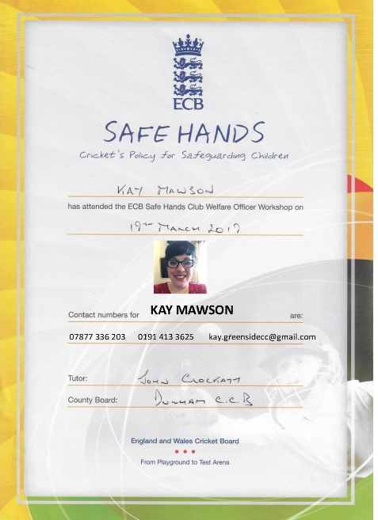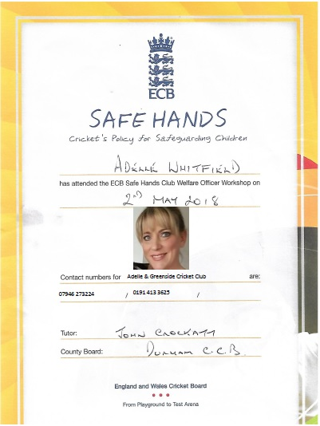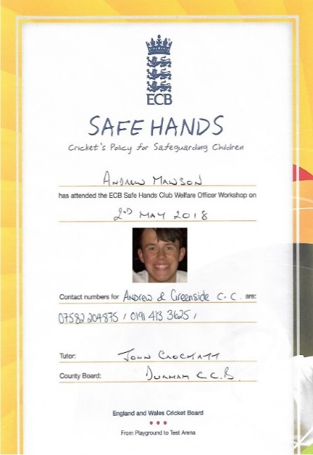

One daft photo could change your life and future in cricket.
Think Twice
It may not be funny to someone else.

ANTI – BULLYING
POLICY

GREENSIDE CRICKET CLUB

Statement of intent
We are committed to providing a caring, friendly and safe environment for all of our children so they can train, and play, in a relaxed and secure atmosphere. Bullying of any kind is unacceptable at our club. If bullying does occur, all children should be able to tell, and know, incidents will be dealt with promptly and effectively. We are a TELLING club. This means anyone who knows bullying is happening is expected to tell someone who can do something about it.
What is bullying?
Bullying is the use of aggression with the intention of hurting another person. Bullying results in pain and distress to the victim
Bullying can take many forms :
- Emotional:
  - being unfriendly, excluding, tormenting (for example: hiding kit, or making threatening gestures)
- Physical:
  - pushing, hitting, kicking, punching or any use of violence
- Racist:
  - racial taunts, graffiti and/or gestures
- Sexual:
  - unwanted physical contact or sexually abusive comments
- Homophobic:
  - because of, or focusing on, the issue of sexuality
- Verbal:
  - name-calling, sarcasm, spreading rumours and teasing
- Cyber:
  - bullying behaviour online or via electronic communication (email and text, social media etc)
  - Misuse of associated technology, such as camera and video facilities

Why is it important to respond to Bullying?
Bullying hurts.
No one should be a victim of bullying. Everyone has the right to be treated with respect. Children who are bullying also need to learn different ways of behaving.
Cricket clubs have a responsibility to respond promptly, and effectively, to issues of bullying.

Objectives of this policy
- All adults and children at the club should understand what bullying is.
- All officials, coaching and non-coaching staff should know what the club policy is on bullying, and follow it when bullying is reported
- All children and parents should know what the club policy is on bullying, and what they should do if bullying arises
- As a club, we take bullying seriously Children and parents should be assured they will be supported when bullying is reported
- Bullying will not be tolerated

Signs and symptoms
A child may indicate, by signs or behaviour, that he or she is being bullied. Adults should be aware of signs and investigate if a child:
- Says they are being bullied
- Changes their usual routine
- Is unwilling to go to the club
- Becomes withdrawn anxious, or lacking in confidence
- Comes home with clothes torn or belongings damaged
- Has possessions which are damaged or go missing
- Asks for money or starts stealing money (to pay the bully)
- Has unexplained cuts or bruises
- Is frightened to say what’s wrong
- Gives improbable excuses for any of the above
In more extreme cases, the child:
- Starts stammering
- Cries themselves to sleep at night or has nightmares
- Becomes aggressive, disruptive or unreasonable
- Is bullying other children or siblings
- Stops eating
- Attempts or threatens suicide or runs away
These signs and behaviours could indicate other problems, but bullying is a possibility and should be investigated.
Procedures
- Report bullying incidents to the Club Welfare Officer-Adelle Whitfield
- In cases of serious bullying, the incidents will be reported to the ECB Safeguarding Team for advice via the County Welfare Officer
- Parents should be informed and invited to a meeting to discuss the problem
- If necessary, and appropriate, police will be consulted
- The bullying behaviour or threats of bullying must be investigated, and the bullying stopped quickly
- An attempt will be made to help the bully (bullies) change their behaviour
In cases of adults reported to be bullying cricketers under 18, the ECB must always be informed and will advise on action to be taken.

Prevention
We will use ‘Kidscape’ recommended methods to help children prevent bullying. These may include:
- Developing a children’s code of conduct (see guidance in ‘Safe hands’
- Agreeing behaviour contracts
Having discussions about bullying and why it matters

PHOTOGRAPHY AND VIDEO CAMERA GUIDELINES
POLICY

GREENSIDE CRICKET CLUB
Feb 2019
The club understands that photos are important for making memories and marking a child’s milestone. However, we have a duty towards those people who have completed their form asking that we do not take images or videos of their child. We would like to stress that this request would apply to any other devices used by fellow members of the Cricket Club too.
If you wish to take photos, speak to a member of the Cricket Club who can confirm if you can do so at the safety of other children who may appear on your photo alongside or in the background of your image or footage. If permission has been granted for images to be taken of your child, please consider cropping the image before uploading to any social media platform.
If a parent selects that they do not want images or footage to be taken of their child, we do not ask the question why and simply adhere to their request based on protection and privacy.
If you become aware that someone is taking photographs or footage of children in the grounds of the cricket club which cause you concern or suspicion, please make a member of staff aware without hesitation. We do not like to alarm those who attend as a family to the club, but we do like to ensure the safety of the children and the environment to which the sport is played.
Food Allergies, Intolerance or Dietary Needs
As an all-inclusive Cricket Club, we would like you to tell us about your needs.
It may be that you have allergies or intolerances. Or it might be that you follow a diet based on your Religion.

Please speak to our staff about ingredients or requirements for any time you attend the club where food will be served such as ‘Cricket Teas’
Thank you.

GREENSIDE CRICKET CLUB
Who’s who

Executive Committee.
DARREN STEPHENSON
CHAIRPERSON
(PART-TIME SECRETARY)

PAUL CLYDESDALE
VICE - CHAIRMAN
BAR MANAGER
KAY MAWSON
TREASURER
(PART-TIME SECRETARY)

Management Committee.
ADELLE WHITFIELD
CLUB WELFARE OFFICER
DARREN STEPHENSON
CLUB DEVELOPEMENT OFFICER

PAUL REED JNR
GROUNDSTAFF
ROSS WHITFIELD SNR
GROUNDSTAFF
CLAIRE RYE
FUNDRAISING OFFICER

OWEN REED
GROUNDSTAFF
VAL BARRON
FUNDRAISING OFFICER

IAN MURRAY
2ND TEAM CAPTAIN
ANDREW KING
1ST TEAM CAPTAIN
DEBBIE REED
SOCIAL MEMBER

DAVE SCOTT
SOCIAL MEMBER
JACKIE MURRAY
SOCIAL MEMBER
MICHELLE WEYMSS
SOCIAL MEMBER
HANNAH REAY
SOCIAL MEMBER

Junior Committee.
ROSS WHITFIELD SNR.
JUNIOR CHAIRPERSON
ADELLE WHITFIELD
JUNIOR TREASURER
HELEN BOWNES
JUNIOR SECRETARY

ROSS WHITFIELD
PARENT
DAVE LUMSDEN
PARENT
IAN MURRAY
PARENT
REBECCA DAVISON
PARENT

Greenside Cricket Club
Low Greenside, Tyne & Wear NE40 4AA
Tel: 0191 413 3625 Email: greensidecricketclub@gmail.com
www.greensidecricketclub.co.uk
MEMBERS OF THE NORTHUMBERLAND & TYNESIDE CRICKET LEAGUE
And
THE HETTON LYONS SUNDAY CRICKET LEAGUE.
2019 Subscriptions.
Thank you for being part of Greenside Cricket Club for the 2018 season.
The Committee have decided that players Subs will remain the same as previously set out in the AGM held in February 2018, which explained how fees are
essential to the annual costs of the Club and an integral part of keeping ours and your insurance valid.
• It should be noted, that insurance cover may very well be invalidated if your membership fees have not been paid in accordance with Club Rules.
• Additionally, it is part of Club-Mark accreditation that we have valid insurance and that we hold “Member Registration Forms” for everyone.
Please ensure you complete this form on the back.

Please complete & tear off the slip below, taking an image (phone camera) for your records & return it along with the appropriate fee if paying by cash or cheque. Envelopes are provided behind the bar which needs to be marked:

FAO: Kay Mawson – Treasurer.

(Please note that this is not a registration form)

 |  |  |  | Payment Options
Method |  | Details |  |  | ☑ |  |  | Sub Type |  |  | Details |  | £ | ☑
Cheque |  | Payable to: Greenside Cricket Club |  |  |  |  |  | FAMILY |  |  | 2 x Adults & 2 x Junior incl. Social |  | £65
Cash |  | One off or Monthly - 1x £15, 5x £10 April to September 2018 |  |  |  |  |  | SENIORS |  |  | Senior Player Incl. Social |  | £65
Chip & Pin |  |  |  |  |  |  |  | LADIES |  |  | Lady Player Incl. Social |  | £50
BACS |  | Account details: Greenside Cricket Club, Lloyds Bank (Blaydon) SC : 30-19-54, Ac : 01124596 |  |  |  |  |  | SOCIAL |  |  | Social Membership Only |  | £10

CLUB MEMBER - REGISTRATION FORM 2019
Please ensure that the club have a completed registration form including, contact details for you in order to notify you of updates, changes, cancellations, events and most importantly, NOK information in case of emergencies.
Please note that all information is held confidentially.
TYPE OF MEMBERSHIP: Senior Player / Family / Social (please delete as appropriate)
 | FULL NAME |  |  | D.O.B. | AGE | SCHOOL | EMAIL ADDRESS |  |  | CONTACT NUMBER
1
2
3
4
5
6
FULL ADDRESS
 |  |  |  |  |  |  |  | POST CODE
EMERGENCY CONTACT (if different from above) |  |  |  | NAME
ADDRESS |  |  |  |  |  |  |  |  | POST CODE
CONTACT NUMBER 1 |  |  |  |  |  |  | ALTERNATIVE CONTACT
MEDICAL INFORMATION: (tell us about anything we would need to know about the members above in the event of an emergency. i.e. Allergies, inhalers or medical conditions etc)

SIGNED |  | PRINT NAME |  | DATE
( please note: by signing this form you and all people listed are agreeing to abide by the rules of the club and are understanding that membership fees are payable in full by 31st May of the current year. You also give consent for management and junior committee members also the clubs coaching staff to take photos of the people listed above during matches, training and social events and are happy for them to be used our the club's website and social media platforms. If you DO NOT AGREE, please place a tick in the box □).

Your Responsibility:
Attached within this booklet are several policies that we need every member to understand and adhere to make this club a safe place. It is your responsibility as a young adult or parent, to make sure you fully understand this pack and ask any questions if you don’t.

We now require you to sign below to confirm that:
- You have received this pack
- You agree to read through and follow what is outlined
- You agree to make payment of your Subscription as a member in full by 31st May 2019, or
- You agree to make regular instalments each month to clear the amount before the end of August.

Sign:
Date:

